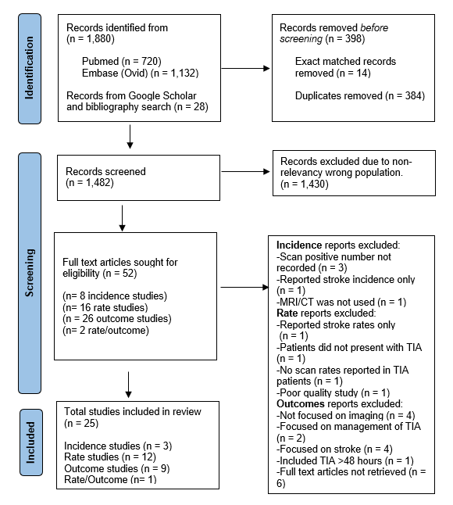
Figure 1: PRISMA diagram showing flow of studies in the review

